1. 
   1. On line 9, the color and text align properties don't have a semicolon.
   2. On line 10, the padding and font-weight properties don't have a semicolon;
2. 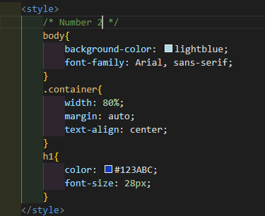
   1. On line 9 ,the background color property doesn’t have a colon.
   2. On line 10, the font-family property doesn’t have a colon and a semicolon.
   3. On line 14, the margin property doesn’t have a colon.
   4. On line 15, the text-align property doesn't have a colon.
   5. On line 19, font size property should be spelled as “font-size”.
3. 
   1. The Link tag shouldn’t have a **“ / “**
4. 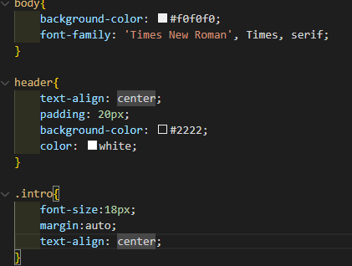
   1. On line 3, it’s missing ‘ times ‘. It should be font-family: “Times New Roman”, times, serif;
   2. On line 7, the text align properly doesn’t have a semi-colon.
   3. On line 9, the color format is invalid.
   4. On line 10, the color property doesn’t have a semi-colon.
   5. On line 14, the font-size property doesn’t have a colon.
   6. On line 16, the text align property doesn’t have a colon.

<https://github.com/KenFemboy/UMTCIT/tree/main/SecondYRSecondSem/It9/Activity_02_20_2025>